“ ACKNOWLEDGEMENT PAGE ”

UNIVERSITY OF MUMBAI



**M.sc (Computer Science)**

“PROJECT OF IOT FOR OPTIMIZATION”

SUBMITTED BY

MR. SURAJ BHUSHAN MISTRI

UNDER THE GUIDANCE OF

MS.RASHMI BAROT POTE

TO

UNIVERSITY OF MUMBAI

IN PARTIAL FULFILMENT OF

F.Y.M.SC (COMPUTER SCIENCE)

SEM-2ST

ACADEMIC YEAR 2022-2023

“ CERTIFICATE PAGE”

UNIVERSITY OF MUMBAI



**M.sc (Computer Science)**

**CERTIFICATE**

This Certified that the work entered in this Project done by the

Student **Mr. SURAJ BHUSHAN MISTRI**

Roll No.**41** of the Class – **Msc Computer Science First Year SEM 2** Semester during the year 2021-2022 in a satisfactory manner.

# ACKNOWLEDGEMENT

On the submission of my project report on “**WATER LEVEL CONTROLLER USING ARDINO UNO**”, we would like to extend our gratitude and sincere thanks to our supervisor **MS. RASHMI BAROT POTE** for her constant motivation and support during the course of my work in the last one year. I truly appreciate and value her esteemed guidance and encouragement from the beginning to the end of this project .I was indebted to Them for having helped me shape the problem and providing insights towards the solution.

I would like to express my thanks towards **MS. RASHMI BAROT POTE**, for their kind co-operation and encouragement, which help me in completion of this project.

Above all, we would like to thank all our friends whose direct and indirect support helped us complete our project in time. The project would have been impossible without their moral support.

### SURAJ BHUSHAN MISTRI

# INDEX

|  |  |  |
| --- | --- | --- |
| **SR. NO** | **INDEX** | **PAGE NO.** |
| **1** | **INTRODUCTION** | **2** |
| **2** | **WORKING** | **3** |
| **3** | **FLOWCHART** | **4** |
| **4** | **CONCLUSION** | **47** |
| **5** | **REFRENCES** | **47** |

# INTRODUCTION

Water level controllers are important for many different industries. For example, cooling towers use water level indicators to monitor water levels in a tank and make corrective actions based on the level of water. Without water level indicators the water tank, has to be check manually whether enough water is in the tank or not and if the tank ever go empty, it mean your chill overheating. Water level indicators allow water levels you to remotely monitor and make corrective actions automatically so you can focus on more important works.

A water level controller is a system that relays information back to a control panel to indicate whether a body of water has a high or low. Some water level indicators use a combination of probe sensors or float switches to sense water levels. “The Water Level Indicator employs a simple mechanism to detect and indicate the water level in an overhead tank or any other water container”.

The purpose of a water level indicator is to gauge and manage water levels in a tank. The control panel can also be programmed to automatically turn on or torn off the water pump once levels get too high the indicator will send you a notification first that you can turn off the pump manually from your smart device if in case device will not get the manual command the pump will get automatically off and the water filling process will stop.

A combination of high and low sensors is used to tell the control panel, when water levels are too high or too low. The control panel will automatically turn the pump on or off depending on the action needed at that time.

.

# WORKING

* + Water level indicators can be used in areas to detect the level of water logged in particular vicinity.
  + When water level crosses a particular mark, the indicator will notify about the real time levels of water.
  + With part the water level indicator we can use a ultrasonic sensor for real time monitoring. Images we will implemented.
  + The water level sensor indicates the percentage of water in LCD display. Also, we can access the raw data in android application.
  + Here we are used Database connectivity which will show the raw data via Firebase database, Arduino uno have inbuilt wifi module so we can access the internet.
  + Arduino uno send the raw data to the database and the android application is connected to the database, so it will display in application.

**Flowchart:**

###### Working of Arduino uno

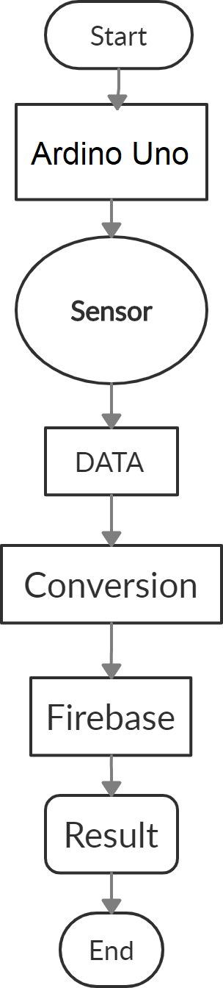

* + **Circuit Diagram**

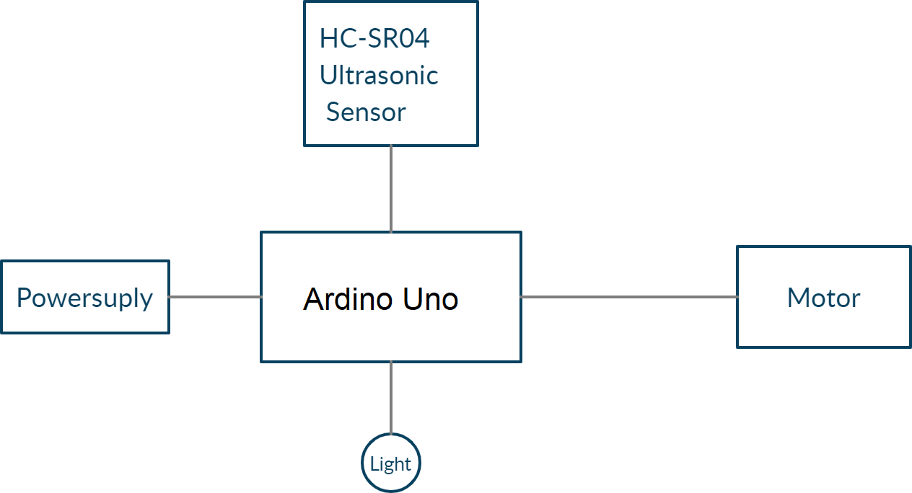

# CONCLUSION

There is certain automated water level controller in practice but they are used for various applications and have some shortness in practice. We tried to suggest ways to tackle this problem and implement an efficient water level controller. The main motto of this project is to design a system which will monitor the water level on daily bases in industries, homes and many places also intimates the concerned authority when the water level exceeds the limit.

We have been using a micro controller to manage the data and to reduce the cost. We have been successfully conducting the experiments in lab and therefore proposed an app-based water level controller through the network whose flexibility would offer us to control the system from any place via access to app data with different type of devices. This type of system is more helpful in situations like floods, water loggings it will check the water levels and react according the situation. This could have a substantial benefit to the research work related to the efficient management of water at urban areas.

From the project, I conclude that the pings without using a timer and by using a timer. It can be concluded that the longer the delay given the more accurate the sensor readings to the water level. The water container at working mode can be concluded that when the pump from running to stop, the error of reading level from the sensor because it is caused by the flow of water that causes the surface of the water is not flat so the reflection pulse not perfect any more

**REFRENCES**

* + google/GitHub/
  + stackoverflow.com/teams/
  + [www.scihub.com/team](http://www.scihub.com/team)
  + [www.youtube.com/codewithharry/](http://www.youtube.com/codewithharry/)
  + [www.tutorialspoint.com/online_jquery_editor.php](http://www.tutorialspoint.com/online_jquery_editor.php)

**Output**

